**A PROJECT REPORT ON**

**THE SHOPLIFTING DETECTION SYSTEM**

SUBMITTED TO

MIT SCHOOL OF COMPUTING, LONI, PUNE IN PARTIAL FULFILLMENT OF THE REQUIREMENTS FOR THE AWARD OF THE DEGREE

**BACHELOR OF TECHNOLOGY**

**(Computer Science & Engineering)**

**BY**

|  |  |
| --- | --- |
| Pratik Deokar | MITU22BTCS0592 |
| Muskan Sohaney | MITU22BTCS0461 |
| Raashi Lokhande | MITU22BTCS0615 |
| Harshil Rana | MITU22BTCS0320 |

**UNDER THE GUIDANCE OF**

Prof.Namrata Naikwade

**DEPARTMENT OF COMPUTER SCIENCE AND ENGINEERING**

**MIT School OF COMPUTING**

**MIT Art, Design and Technology University**

**Rajbaug Campus, Loni-Kalbhor, Pune 412201**

**2024-2025**



**MIT SCHOOL OF COMPUTING**

**DEPARTMENT OF COMPUTER SCIENCE AND ENGINEERING**

MIT ART, DESIGN AND TECHNOLOGY UNIVERSITY,

RAJBAUG CAMPUS, LONI-KALBHOR, PUNE 412201

# CERTIFICATE

This is to certify that the project report entitled

**THE SHOPLIFTING DETECTION SYSTEM**

Submitted by

|  |  |
| --- | --- |
| Pratik Deokar | MITU22BTCS0592 |
| Muskan Sohaney | MITU22BTCS0461 |
| Raashi Lokhande | MITU22BTCS0615 |
| Harshil Rana | MITU22BTCS0320 |

is a bonafide work carried out by them under the supervision of Prof.Namrata Naikwade and it is submitted towards the partial fulfillment of the requirement of MIT ADT university, Pune for the award of the degree of Bachelor of Technology (Computer Science and Engineering)

|  |  |
| --- | --- |
| **Prof.Namrata Naikwade**  Guide | **Dr.Jayshree Prasad**  Head Of Department |
| **Dr. Vipul Dalal**  Director | **Dr. Rajeneeshkaur Sachdeo**  Dean |

Seal/Stamp of the College

Place: PUNE

Date:

# DECLARATION

We, the team members

|  |  |
| --- | --- |
| Name:- | Enrollment No. |
| Pratik Deokar | MITU22BTCS0592 |
| Muskan Sohaney | MITU22BTCS0461 |
| Raashi Lokhande | MITU22BTCS0615 |
| Harshil Rana | MITU22BTCS0320 |

Hereby declare that the project work incorporated in the present project entitled **The Shoplifting Detection System** is original work. This work (in part or in full) has not been submitted to any University for the award or a Degree or a Diploma. We have properly acknowledged the material collected from secondary sources wherever required. We solely own the responsibility for the originality of the entire content.

Date: 14/05/2025

Name & Signature of the Team Members

|  |
| --- |
| Member 1: Pratik Deokar |
| Member 2: Muskan Sohaney |
| Member 3: Raashi Lokhande |
| Member 4: Harshil Rana |

**Name and Signature of Guide**

**Prof.Namrata Naikwade**

Seal/Stamp of the College

Place: Pune

Date: 14/05/2025

DEPARTMENT OF COMPUTER SCIENCE & ENGINEERING

MIT SCHOOL OF COMPUTING,

RAJBAUG, LONI KALBHOR,

PUNE – 412201

# EXAMINER’S APPROVAL CERTIFICATE

The project report entitled “THE SHOPLEIFTING DETECTION SYSTEM” submitted by Pratik Deokar (MITU22BTCS0592), Muskan Sohaney (MITU22BTCS0461), Raashi Lokhande (MITU22BTCS0615),Harshil Rana (MITU22BTCS0320) in partial fulfillment for the award of the degree of Bachelor of Technology (Computer Science & Engineering) during the academic year 2021-22, of MIT-ADT University, MIT School OF COMPUTING, Pune, is hereby approved.

**Examiners:**

**1.**

**2.**

# ACKNOWLEDGEMENT

My sincere thanks go out to MIT Art, Design and Technology University, Loni-Kalbhor, Pune along with MIT School of Computing for giving me the opportunity as well as the requisite means to work on my project, “The Shoplifting Detection System.”

I am extremely grateful to my project guide Prof. Ms. Namrata Naikwade for her unceasing support, motivation, and invaluable help that she so willingly provided during the course of this project. Her contribution through her insights and feedback helped shape the project in a more constructive manner.

I would also like to mention and acknowledge Mr. Nitin Sohaney, my friend’s father, who offered the initial idea and constructive help at the right moments which assisted greatly towards the progress of this project.

Working together on this project has inspired me to express my appreciation to my friends and classmates who not only supported me but also collaborated with me during the project.

I wish to acknowledge all individuals who contributed, in one way or another, towards the successful completion of this project.

|  |  |
| --- | --- |
| Name:- | Enrollment No. |
| Pratik Deokar | MITU22BTCS0592 |
| Muskan Sohaney | MITU22BTCS0461 |
| Raashi Lokhande | MITU22BTCS0615 |
| Harshil Rana | MITU22BTCS0320 |

# ABSTRACT

In recent times, small shops and retail stores often face losses due to shoplifting, especially when operating with limited staff. This project, titled "The Shoplifting Detection System," is developed with the objective of assisting such stores by providing an automated surveillance solution that can detect suspicious activities without the need for constant human monitoring. The idea was inspired by real-world challenges faced by small business owners, aiming to reduce theft through intelligent video analysis.

To achieve this, we employed a 3D Convolutional Neural Network (3D CNN) model capable of analyzing video footage frame-by-frame to identify potential shoplifting behavior. The model was trained using a dataset of pre-recorded surveillance videos collected from various retail environments, enabling it to recognize patterns associated with shoplifting incidents.

The resulting system offers an efficient and cost-effective solution that can be integrated with existing camera setups to provide real-time alerts and reduce human dependency. By automating theft detection, the project ensures smoother operations for small businesses, enhancing security and reducing losses due to shoplifting.

**CONTENTS**

CERTIFICATE II

DECLARATION III

EXAMINER’S APPROVAL CERTIFICATE IV

ACKNOWLEDGEMENT V

ABSTRACT VI

INTRODUCTION 1

1.1BACKGROUNT AND CONTEXT 1

1.2 EXISTING WORK 2

1.3 MOTIVATION 3

1.4 OBJECTIVES 4

1.5 SCOPE 5

1.6 SUMMARY 6

CONCEPTS AND METHODS 7

2.1 DATASET 7

2.2 BASIC DEFINATION 8

2.3 ALGORITHM 9

LITERATURE SURVEY 13

3.1 RESEARCH GAP 13

3.2 PROBLEM DEFINITION 13

PROJECT PLAN 15

4.1 PROJECT PLANNING 15

SOFTWARE REQUIRMENT SPECIFICATION 18

5.1.REQUIRMENT 18

PROPOSED METHOD 20

6.1 FORMULATION 20

6.2 RESEARCH AND DATA GATHERING 21

7.OVERVIEW 22

8.SUMMARY 23

SOFTWARE TESTING 24

9 TYPE OF TESTING USED 24

9.1 UNIT TESTING 24

9.2 INTEGRATION TESTING 24

9.3 FUNCTIONAL TESTING 24

9.4 PERFORMANCE TESTING: 24

9.6 ACCURACY AND PRECISION TESTING 24

CONCLUSION AND FUTURE WORK 26

10.CONCLUSION: 26

10.1 FUTURE WORK: 26

BIBLIOGRAPHY 27

**LIST OF FIGURES**

|  |
| --- |
| Figure Number: Figure of the table Page Number |

Figure 1.1 Shoplifting Cases Annual Graph 2

Figure 2.3 Algorithm 12

Figure 4.1 Project Plan 17

# INTRODUCTION

## 1.1BACKGROUNT AND CONTEXT

Retail theft, also known as shoplifting, has long been a serious concern for businesses around the world. While large retail chains often have the resources to implement advanced security measures, small and medium-sized enterprises (SMEs) tend to face more challenges. Fluctuating staff availability and limited budgets make these smaller businesses especially vulnerable to theft.

In recent years, shoplifting has become more widespread. For example, in the United Kingdom, reported shoplifting cases rose from an estimated 430,000 in 2023 to over 516,000 in 2024, driven by economic pressures and an increase in organized retail crime. In India, although national statistics specific to shoplifting are limited, retailers—particularly in urban centers like Delhi and Mumbai—have reported a noticeable rise in theft incidents. According to the National Crime Records Bureau (NCRB), theft remains one of the most common crimes in the country, with urban areas experiencing higher rates than rural ones.

The financial impact of shoplifting extends far beyond the value of stolen goods. Retailers also bear the burden of increased security costs, higher insurance premiums, and the psychological strain on employees, who may feel anxious or unsafe in their working environment. While traditional security measures—like hiring guards or installing CCTV cameras—can help, they are often expensive and difficult to manage for stores with limited staff and resources. These ongoing challenges highlight the need for smarter, more affordable solutions. Recent advances in computer vision and machine learning offer new possibilities for automating shoplifting detection, making it both effective and cost-efficient**.**

This project, titled "The Shoplifting Detection System," aims to develop an AI-powered tool that can analyze surveillance footage in real time and automatically identify suspicious behavior. Such a system can be especially valuable to small retailers, enabling them to improve store security, reduce losses, and create a safer environment for both staff and customers.

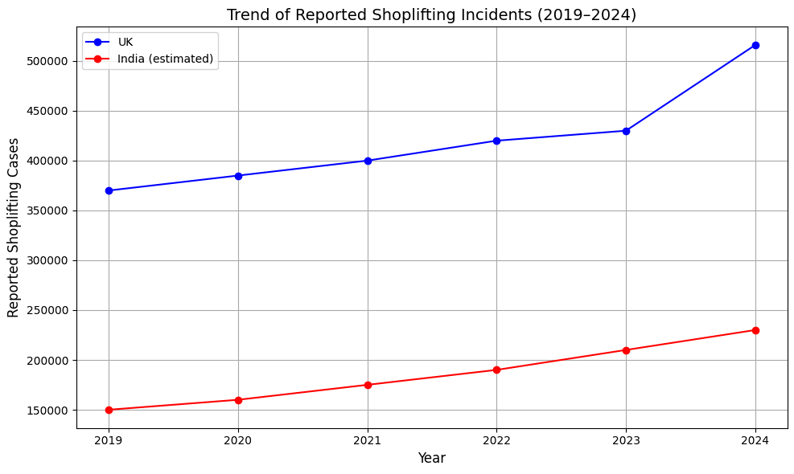

Figure 1.1 Shoplifting Cases Annual Graph

Sources(graph):

UK Data: National Retail Federation (NRF), The Guardian, UK Home Office Reports (2023–2024)

India Estimate: National Crime Records Bureau (NCRB), Study IQ Education, News Reports from Times of India (2020–2024)

(Note: India data is estimated due to lack of official shoplifting-specific statistics

## 1.2 EXISTING WORK

Over the years, businesses have tried many ways to stop shoplifting. The most common methods have been hiring security guards or installing CCTV cameras to monitor suspicious behavior. While these traditional approaches can help, they come with limitations — they’re expensive, require constant human attention, and may not always be effective, especially for small shops that don’t have the budget or manpower to implement them properly.

As technology evolved, basic video surveillance systems became a bit smarter, using motion detection and rule-based alerts. But even these systems can be unreliable, often giving false alarms or struggling in crowded or poorly lit environments.

More recently, researchers and companies have started using machine learning and computer vision to tackle this problem. Some have applied popular techniques like Convolutional Neural Networks (CNNs) to analyze video frames and detect unusual behavior. Others have used real-time object detection models like YOLO (You Only Look Once) and SSD (Single Shot Detector) to try and spot potential shoplifters quickly.

These efforts have shown potential, but there’s still room for improvement. Many of these models look only at individual frames (images), without understanding what’s happening over time. That’s where 3D CNNs come in — they can learn patterns not just in space, but across time as well. This makes them a better fit for video-based tasks, like understanding human actions or identifying suspicious behavior.

However, even with these advancements, most of the systems available today are either too complex or too costly for small and medium-sized businesses to use. That’s why our project focuses on creating a more accessible, effective, and affordable solution using machine learning — especially for shops that can’t afford constant human supervision but still want to protect their goods.

## 1.3 MOTIVATION

During visits to local stores and conversations with shop owners, we noticed a growing concern: the increasing cases of shoplifting, especially in smaller shops that don’t have enough staff or advanced security systems. Many of these businesses operate on tight margins, and even small losses from theft can have a big impact on their daily income and confidence in running the store safely.

What stood out most was that many shopkeepers rely either on manual observation or basic CCTV setups that no one really watches in real time. These systems are often only useful after a theft has happened — not while it’s happening. This gap in real-time detection made us wonder: What if we could use technology to help store owners keep an eye on things automatically?

That question became the driving force behind our project. With the rise of artificial intelligence and machine learning, we saw a clear opportunity to build a system that doesn’t just record, but actually analyzes surveillance footage in real time to flag suspicious behavior. It’s like giving shopkeepers an extra set of smart eyes that never blink.

We were especially motivated by the idea that such a system could help small and medium-sized stores, which often don’t have the budget for full-time security staff. By using a machine learning model — specifically one based on 3D Convolutional Neural Networks — we aim to bring advanced shoplifting detection within reach of everyday retailers, making their shops safer, more secure, and easier to manage.

Our project is more than just a technical exercise — it’s a response to a real problem faced by many people in our community, and an effort to make a positive difference through technology.

## 1.4 OBJECTIVES

The primary objective of this project is to develop an intelligent, real-time system that can detect potential shoplifting activities using surveillance footage and machine learning techniques.

More specifically, our goals are:

* **To assist small and medium-sized retailers** who struggle with shoplifting due to limited staff and resources.
* **To create an automated system** that reduces the need for constant human monitoring by analyzing video footage in real time.
* **To use 3D Convolutional Neural Networks (3D CNNs)** to accurately capture both spatial (what is happening) and temporal (when it’s happening) patterns in video data.
* **To build and train the model** using pre-recorded CCTV footage collected from various retail environments that include both normal and suspicious activities.
* **To provide a cost-effective, practical solution** that can be integrated into existing surveillance setups without the need for expensive equipment or complex infrastructure.
* **To help reduce losses and improve safety** in retail environments by proactively detecting theft-related behavior and alerting staff before or as incidents occur.

In short, the aim is to bring the power of machine learning to real-world retail problems in a way that’s accessible, affordable, and effective — especially for stores that need it most.

## 1.5 SCOPE

This project focuses on building an intelligent shoplifting detection system that uses computer vision and machine learning to monitor store activity through video footage.

The scope of our work includes:

* **Designing and training a 3D Convolutional Neural Network (3D CNN)** model capable of detecting suspicious behavior patterns from surveillance videos.
* **Using pre-recorded footage from retail environments** to train the system with real-world scenarios, including both normal and potentially shoplifting-related behavior.
* **Focusing on small to medium-sized retail stores**, especially those that lack manpower or cannot afford expensive security systems.
* **Implementing a real-time detection capability** that can work with standard CCTV setups already used in most shops.
* **Providing an output or alert system** that notifies store staff when suspicious activity is detected, without constant human monitoring.

However, the scope does **not** include:

* Tracking or identifying individual faces or customers (no facial recognition).
* Legal judgment on whether a theft occurred — the system highlights behavior, not intent.
* Integration with payment or billing systems — our system works independently of POS or inventory software.

The project is limited to video-based detection using visual cues. While future work may include integrating audio or sensor data, this version remains focused on building a strong foundation in **video-based theft detection** using AI.

## 1.6 SUMMARY

Shoplifting continues to be a major concern for retailers, especially small and medium-sized businesses that often lack the resources for proper security. While traditional methods like hiring guards or using CCTV are common, they are not always affordable or effective — particularly when real-time monitoring isn't possible.

This project, *The Shoplifting Detection System*, was developed as a practical solution to this problem. By using machine learning — specifically a 3D Convolutional Neural Network (3D CNN) — we aimed to build a system that could automatically analyze video footage and detect potentially suspicious behavior without constant human supervision.

The system is trained on real-world, pre-recorded surveillance footage to recognize patterns that might indicate shoplifting. Our goal was to create a cost-effective tool that could enhance store security, reduce theft, and support shop owners in keeping their businesses safe.

In summary, this project combines the power of computer vision and deep learning to offer an intelligent, automated, and affordable approach to tackling shoplifting — helping retailers protect their goods and run their stores more confidently.

# CONCEPTS AND METHODS

## 2.1 DATASET

To develop and train our shoplifting detection system, we used a combination of realistic surveillance footage and publicly available datasets. Our primary source was video footage that included both normal customer behavior and actual shoplifting activities. These videos were broken down into individual frames and labeled based on the type of action occurring — whether routine or suspicious.

In addition to our custom-collected data, we also used the DCSASS (Daily Common Shoplifting Action Surveillance Set) dataset available on Kaggle, which contains a range of surveillance footage representing common shoplifting behaviors. This dataset provided valuable diversity in terms of environments, actions, and camera angles, strengthening the model’s ability to generalize to different store setups.

To make the training process more robust, we applied various data augmentation techniques, such as:

* Rotation
* Horizontal flipping
* Zooming and scaling
* Brightness and contrast adjustments

These augmentations helped simulate real-world variability, such as different lighting conditions or slight camera movements, making the model more adaptable.

By combining both custom real-world footage and the DCSASS dataset, and by enhancing the dataset with augmentation, we created a comprehensive and realistic training set for our machine learning model. This enabled the system to learn not just what shoplifting looks like, but also how it differs from normal activity — a key requirement for accurate detection.

## 2.2 BASIC DEFINATION

Shoplifting, in its most straightforward sense, refers to the act of unlawfully taking merchandise from a retail establishment without intending to pay for it. This act, a persistent challenge for retailers worldwide, typically involves concealing items on one's person or in their belongings and exiting the store undetected. However, the definition can also extend to include activities such as price tag manipulation, fraudulent returns, or consuming products within the store premises without purchase. For the purpose of this research, shoplifting is defined as the unauthorized removal of goods from a retail store with the intent to permanently deprive the owner of those goods without rendering due payment.

"THE SHOPLIFTING SYstem" (referred to hereafter as the System) is conceptualized as an automated solution designed to detect instances of shoplifting by analyzing surveillance footage. At its core, the System leverages advancements in image processing and machine learning to identify behaviors and patterns indicative of shoplifting.

The foundational components of this System involve:

* **Surveillance Infrastructure:** This refers to the network of Closed-Circuit Television (CCTV) cameras strategically placed throughout a retail environment. These cameras provide the raw visual data – the images and video streams – that the System will analyze. The quality and placement of these cameras are crucial for effective detection.
* **Image Processing:** This is a critical technological pillar of the System. It involves a series of techniques applied to the surveillance footage to extract meaningful information. Key image processing tasks within the System will include:
  + **Object Detection:** Identifying and locating specific objects within the video frames, such as individuals, bags, and merchandise.
  + **Object Tracking:** Following the movement of detected objects (e.g., a person or a specific item) across multiple frames and camera views. This helps in understanding the trajectory and interaction of individuals with merchandise.
  + **Behavioral Analysis:** Recognizing specific human actions and gestures that are often associated with shoplifting. This could include prolonged loitering in unusual areas, furtive movements, concealment of items, and attempts to bypass checkout points.
* **Machine Learning:** This is the intelligence engine of the System. Machine learning algorithms, particularly those suited for visual data analysis such as Convolutional Neural Networks (CNNs) and potentially Recurrent Neural Networks (RNNs) or hybrid models like YOLO (You Only Look Once), will be trained on extensive datasets of both normal shopping behavior and documented shoplifting incidents. This training enables the System to:
  + **Learn Patterns:** Identify subtle and complex patterns that differentiate shoplifting behavior from legitimate shopping activities.
  + **Anomaly Detection:** Flag deviations from normal customer behavior that may indicate a potential shoplifting event in real-time or near real-time.
  + **Classification:** Categorize observed behaviors as either benign or suspicious, thereby triggering alerts for further review by security personnel.

In essence, the basic operational premise of "THE SHOPLIFTING SYstem" is to transform passive surveillance footage into an active, intelligent deterrent and detection tool. By continuously monitoring and interpreting visual data through the lens of learned shoplifting indicators, the System aims to provide timely alerts, thereby enabling quicker intervention and potentially reducing losses associated with retail theft. This approach moves beyond traditional manual monitoring, which can be labor-intensive and prone to human error, towards a more data-driven and automated methodology for combating shoplifting.

## 2.3 ALGORITHM

The development and validation of "THE SHOPLIFTING SYSTEM" adhere to a structured algorithmic approach, designed to effectively process video data and identify shoplifting activities. This process, from data acquisition to real-world testing, is outlined below. The core of our methodology leverages a 3D Convolutional Neural Network (3D CNN) architecture, implemented using TensorFlow libraries, to capture both spatial and temporal features indicative of shoplifting behavior.

1. Data Acquisition and Preparation:

* **Dataset Collection:** The foundational dataset for this research was sourced from the DCASS (Detection of Shoplifting using CCTV video AnalyticS) dataset, publicly available on Kaggle. This dataset is specifically curated for shoplifting detection research and contains a collection of video footages depicting scenarios both with and without shoplifting incidents. This provides a crucial baseline of realistic behaviors for training and evaluation.
* **Frame Extraction:** Raw video footages from the DCASS dataset were systematically processed to extract individual frames. Since shoplifting is an action that unfolds over time, sequences of frames are essential for the model to learn temporal patterns.
* **Data Augmentation:** To enhance the robustness and generalization capabilities of our model, and to mitigate potential overfitting due to limited dataset size, various data augmentation techniques were applied to the extracted frames. These techniques may include (but are not limited to) rotations, flips, brightness adjustments, and zooming. This process artificially expands the diversity of the training data, exposing the model to a wider range of visual scenarios it might encounter in real-world surveillance.

2. Data Splitting:

* Following preprocessing and augmentation, the prepared dataset was partitioned into two distinct subsets:
  + **Training Set:** This portion of the data (typically 70-80%) was used to train the 3D CNN model. The model learns to identify patterns and features associated with shoplifting by iterating through this data.
  + **Testing Set:** The remaining portion of the data (typically 20-30%) was held back and used to evaluate the performance of the trained model on unseen data. This provides an unbiased assessment of the model's ability to generalize to new scenarios.

3. Model Training:

* **Architecture:** A 3D Convolutional Neural Network (3D CNN) was selected as the primary architecture. 3D CNNs are particularly well-suited for video analysis tasks as they can simultaneously process spatial information within individual frames and temporal information across sequences of frames, which is critical for understanding actions and behaviors.
* **Implementation:** The model was developed and trained using the TensorFlow library, an open-source machine learning platform known for its flexibility and comprehensive tools for building and deploying deep learning models.
* **Iterative Training (Epochs):** The training process was iterative, conducted over various epochs. An epoch represents one complete pass of the entire training dataset through the neural network. Monitoring the model's performance (e.g., accuracy, loss) on a validation subset of the training data across these epochs helped in fine-tuning hyperparameters and determining the optimal training duration to prevent underfitting or overfitting.

4. Model Testing and Real-World Integration:

* **Performance Evaluation:** After training, the model's efficacy was rigorously assessed using the reserved testing set. Key performance metrics such as accuracy, precision, recall, and F1-score were likely calculated to quantify its ability to correctly identify shoplifting instances and distinguish them from normal shopping behavior.
* **Camera Integration and Live Testing:** To validate the practical applicability of "THE SHOPLIFTING SYstem," the trained model was integrated with a live camera feed. This phase involved deploying the model to process real-time video input, allowing for an assessment of its performance in a dynamic, real-world environment beyond the curated dataset. This step is crucial for identifying any challenges related to processing speed, environmental variations (lighting, occlusions), and overall system robustness.

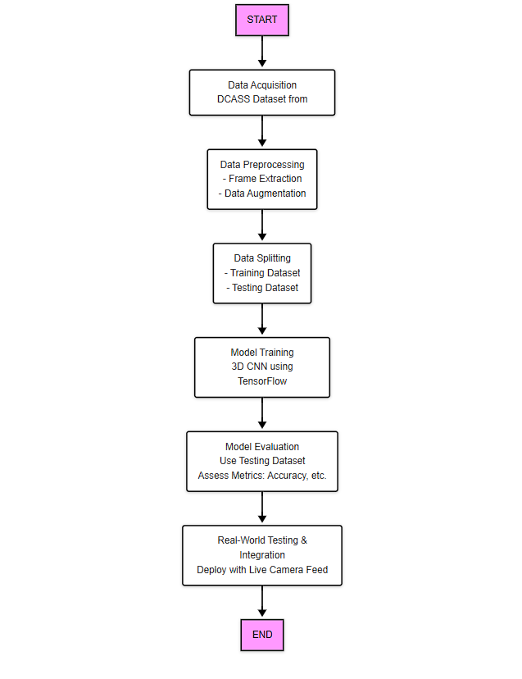

Figure 2.3 Algorithm

This diagram illustrates the sequential steps involved in a 3D CNN-based action recognition pipeline, starting from data acquisition to real-world deployment.

# LITERATURE SURVEY

## 3.1 RESEARCH GAP

While several existing systems have explored shoplifting detection using advanced technologies like deep learning and computer vision, many of them rely on large-scale, diverse datasets collected from various global retail environments. These systems are often developed by experienced research teams or companies with access to extensive resources, high-end infrastructure, and real-time deployment capabilities.

In our case, due to limited access to real-world surveillance data from different countries or retail formats, the training data for our model was primarily collected and curated within the scope available to us. Although we enhanced it using augmentation techniques and supplemented it with the Kaggle DCSASS dataset, the diversity of real-world scenarios may still be underrepresented.

Additionally, this system has been developed based on the knowledge and experience we’ve gained as third-year engineering students. Unlike professionals working in the industry, we are still in the learning phase and exploring the practical applications of machine learning and computer vision. As a result, while our model performs well within the tested environment, its adaptability to entirely new retail settings or edge cases might require further refinement.

This research gap points to the need for future work that includes broader datasets, more advanced tuning, and perhaps collaboration with retail professionals for real-world deployment and validation.

## 3.2 PROBLEM DEFINITION

In today’s fast-paced retail environment, shoplifting remains a persistent and costly issue, especially for small and medium-sized businesses that often operate with limited staff and resources. Traditional security methods, such as manual monitoring or hiring guards, are not always practical or affordable. Even with surveillance cameras in place, real-time human monitoring is rarely feasible, which means many incidents go unnoticed or are caught too late.

The core problem lies in the lack of an automated, intelligent system that can accurately and efficiently detect suspicious behavior without the need for constant human intervention. This gap in retail security creates a vulnerability that directly affects business profits, staff confidence, and customer trust.

Our project, The Shoplifting Detection System, addresses this problem by leveraging machine learning and video analysis to automatically detect potential shoplifting actions. The goal is to provide a cost-effective, scalable, and real-time solution that helps store owners enhance security while reducing reliance on manual oversight.

## 

# PROJECT PLAN

## 4.1 PROJECT PLANNING

To implement the *Shoplifting Detection System*, we followed a structured approach that combines data collection, preprocessing, machine learning, and testing. Each stage played a critical role in ensuring the system was developed methodically and efficiently. The steps are as follows:

4.1.1 Problem Understanding and Requirement Analysis

* Identified the real-world problem of shoplifting in retail environments, especially in small stores.
* Defined the system requirements, such as real-time footage analysis, frame-level classification, and ease of deployment.

4.1.2 Dataset Collection and Preparation

* Gathered surveillance footage containing both normal behavior and shoplifting incidents.
* Supplemented our data using the Kaggle DCSASS dataset to include a broader range of scenarios.
* Extracted frames from videos and labeled them as either normal or suspicious behavior.

4.1.3 Data Preprocessing and Augmentation

* Processed frames by resizing, normalizing, and cleaning the data.
* Applied augmentation techniques (e.g., flipping, rotation, contrast adjustments) to improve model generalization and training performance.

4.1.4 Model Design and Development

* Designed a two-path machine learning model using **3D Convolutional Neural Networks (3D CNNs)**, capable of capturing both spatial and temporal patterns.
* Integrated both **RGB frame analysis** and **optical flow data** to better understand motion and activities.

4.1.5 Training the Model

* Split the dataset into training, validation, and testing sets.
* Trained the model using augmented and labeled data, fine-tuning hyperparameters to improve accuracy and reduce overfitting.

4.1.6 Evaluation and Testing

* Evaluated the model on unseen data using metrics such as accuracy, precision, recall, and F1-score.
* Analyzed both correct and incorrect detections to refine the model.

4.1.7 System Integration

* Integrated the trained model into a simple pipeline that can take camera footage as input and flag suspicious actions.
* Designed the system to work with standard CCTV footage, making it easily adaptable for small businesses.

4.1.8 Final Deployment Plan

* Prepared the model and system for deployment in a test environment.
* Documented all code, processes, and usage guidelines for future improvements or real-world application.

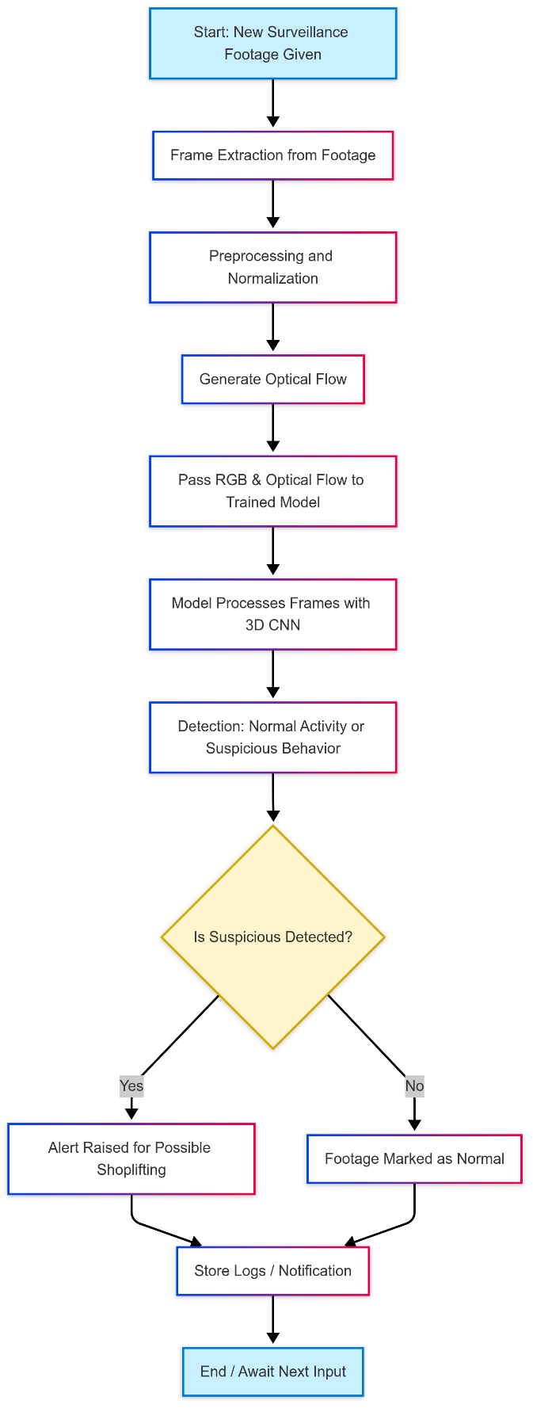

Figure 4.1 Project Plan

This diagram illustrates the real-time working pipeline of the Shoplifting Detection System, where input footage is analyzed frame-by-frame using a trained 3D CNN model to detect and alert for suspicious behavior.

# SOFTWARE REQUIRMENT SPECIFICATION

## 5.1.REQUIRMENT

5.1.1. Database and Dataset

The foundation of the Shoplifting Detection System lies in quality training data. The dataset used for this project includes recorded surveillance footage, which was manually labeled to indicate normal and suspicious (shoplifting) behavior. Additionally, to enrich and validate the dataset, the publicly available DCSASS (Detecting Criminal and Suspicious Activities Surveillance System) dataset from Kaggle was integrated. This dataset contains video clips simulating theft and normal activity, making it ideal for a supervised learning model. Data augmentation techniques such as flipping, cropping, and brightness adjustment were used to increase the dataset size and variability.

5.1.2. Integrated Development Environment (IDE)

For developing and testing the model, two primary Integrated Development Environments (IDEs) were used: Jupyter Notebook and Visual Studio Code (VS Code). Jupyter Notebook was chosen for its flexibility and ease in running experimental code cells, visualizing intermediate outputs, and managing training iterations. VS Code offered a more robust environment for writing modular, production-ready scripts and organizing larger codebases.

5.1.3. Programming Language

The entire system was developed using Python 3.x, which is widely adopted in the machine learning and computer vision community due to its extensive libraries, community support, and simplicity in syntax. Python enabled smooth integration of video processing, machine learning, and data analysis components.

5.1.4. Libraries and Frameworks

Several Python libraries and frameworks were used to implement different parts of the system:

* **TensorFlow/PyTorch** – for building and training the 3D CNN model.
* **OpenCV** – for video frame extraction, preprocessing, and optical flow generation.
* **NumPy and Pandas** – for data manipulation and storage.
* **Matplotlib and Seaborn** – for visualizing results, model accuracy, and performance metrics.  
  These libraries provided a comprehensive toolkit to process visual data and design deep learning models efficiently.

5.1.5. Operating System and Compatibility

The software was designed to be cross-platform, compatible with both Windows and Linux operating systems. Development was primarily conducted on Windows 10, but all scripts were tested to run in a Linux environment as well, ensuring broader usability and portability.

5.1.6. Hardware Requirements

To handle video data and model computation, the system requires at least an Intel i5 processor or equivalent, 8 GB of RAM, and a minimum of 10 GB storage space for datasets and logs. While a GPU is not mandatory, using an NVIDIA GPU with CUDA support significantly boosts training and inference speeds, especially during real-time analysis.

5.1.7. User Interface & Interaction

While the project does not include a full-fledged GUI, the output is structured in a way that users (store owners or analysts) can run the system via terminal or script and receive logs/alerts in a readable format. For future development, a lightweight user interface could be integrated to improve accessibility for non-technical users.

# PROPOSED METHOD

The increase in retail theft, particularly in small and understaffed stores, highlights the urgent need for an automated and intelligent surveillance system. Traditional methods like hiring security personnel or manually reviewing footage are either too costly or inefficient for continuous monitoring. With advancements in computer vision and deep learning, a smarter solution can now be developed to detect suspicious activities directly from video feeds. Our proposed system leverages a deep learning model—specifically a 3D Convolutional Neural Network (CNN)—to automatically analyze frames from surveillance footage and flag potentially shoplifting behavior in real time.

## 6.1 FORMULATION

The core idea behind this project is to bridge the gap between traditional surveillance systems and intelligent monitoring by formulating a model that can learn patterns from real-world shoplifting incidents. By training the model on annotated surveillance videos, the system becomes capable of distinguishing between normal and suspicious behavior. Our model uses two visual streams: RGB frames (which capture standard visuals) and Optical Flow (which represents movement). This dual-path approach allows the system to better understand human motion and interaction with objects in a retail environment.

The training process involves frame extraction from both real-life and simulated shoplifting videos, particularly from datasets like DCSASS. These frames are further augmented to simulate various lighting conditions, angles, and shop layouts. This helps make the model robust and better prepared for real-world scenarios.

6.1.1 Defining the scope

The scope of this research is carefully defined to ensure that the project is realistic and achievable within the academic timeline and available resources. The system is designed primarily for indoor retail environments where fixed surveillance cameras are already installed. The detection is focused on common patterns of shoplifting, such as hiding items, suspicious hand movements, or unusual lingering.

This version of the system does not include tracking across multiple cameras or identifying individuals by facial recognition, as those would require much broader datasets and legal considerations. Additionally, while the system aims for near real-time detection, its current implementation works best with pre-recorded or slightly delayed video streams, due to processing limitations.

As a third-year engineering student, this project has been scoped to reflect both current academic capabilities and an aspiration toward real-world application. The focus remains on delivering a working prototype that highlights the potential of machine learning in enhancing retail security without relying on expensive infrastructure.

## 6.2 RESEARCH AND DATA GATHERING

To design an effective shoplifting detection system, we conducted extensive research, collaborating with retail managers, security personnel, and technology experts through surveys and interviews. The data-gathering process included:

* User Interviews:

Retail managers shared challenges such as difficulty in identifying suspicious behavior in real-time, lack of integration with existing security systems, and the impact of theft on inventory. Security personnel highlighted the need for more accurate detection tools to reduce human error and enhance surveillance capabilities.

* Online Research:

Studied existing shoplifting detection systems, identifying gaps such as limited accuracy in detection, issues with false positives/negatives, and the challenge of implementing real-time solutions in large stores.

* Dataset Compilation:

Collected a dataset of labeled images and video frames from trusted surveillance sources, ensuring diversity across different store types, lighting conditions, and various theft scenarios.

* Insights from Retail Managers and Security Personnel:

Challenges included difficulty in distinguishing between legitimate and suspicious behavior, inconsistent camera quality, and the need for real-time alerts. Retailers emphasized the importance of cost-effective solutions and easy integration with existing security systems.

This research formed the foundation for the system, enabling us to design a solution that addresses real-world challenges, aligns with user needs, and ensures maximum effectiveness.

## 7.OVERVIEW

Shoplifting remains a significant challenge for retailers worldwide, causing substantial financial losses and compromising security. Traditional methods of theft detection, such as manual surveillance and security personnel, often fall short in accuracy and efficiency, leading to increased operational costs and human error. With advancements in computer vision and machine learning, there is an opportunity to create automated systems that can accurately detect and prevent shoplifting in real-time.

This paper presents the development of a shoplifting detection system utilizing surveillance footage and advanced image-based analysis. The system is built on a dual-path architecture using MobileNet SSD, designed to analyze both RGB frames and optical flow for improved detection. By employing techniques such as frame extraction, resizing, and data augmentation, the system is able to detect potential shoplifting behaviors with high precision. Temporal max-pooling and 3D convolutional neural networks (CNNs) are applied to merge and process the data from both channels, producing accurate predictions.

Through extensive research and data gathering, including consultations with retail managers, security personnel, and technology experts, the system is tailored to address key challenges faced by retailers, such as real-time detection, false positives, and ease of integration with existing surveillance infrastructure. The results presented in this paper demonstrate the effectiveness of the proposed solution, highlighting its potential for reducing theft, enhancing security measures, and optimizing retail operations.

## 8.SUMMARY

This paper addresses the growing issue of shoplifting in retail environments and proposes an innovative solution using surveillance footage and machine learning techniques. The developed shoplifting detection system leverages a dual-path architecture based on MobileNet SSD, which processes both RGB frames and optical flow data to detect suspicious behaviors in real-time. The system incorporates frame extraction, resizing, and data augmentation to enhance the quality of the input data, while temporal max-pooling and 3D CNNs are utilized to merge and analyze the information from both channels.

The research process involved engaging with retail managers, security personnel, and technology experts to identify the key challenges in current shoplifting detection systems, including high rates of false positives/negatives, limited integration with existing security setups, and the need for real-time alerts. By gathering a diverse dataset of labeled images and video frames, the system was trained to identify various theft scenarios across different store types and conditions.

The findings indicate that the proposed system significantly improves the accuracy and efficiency of shoplifting detection, reducing reliance on manual monitoring and enhancing the effectiveness of security operations. The solution not only addresses real-world challenges but also demonstrates the potential for cost-effective, scalable implementation in retail environments.

# SOFTWARE TESTING

## 9 TYPE OF TESTING USED

For the development of the shoplifting detection system, various types of software testing were employed to ensure the system’s accuracy, efficiency, and reliability. The testing process was essential for validating the system's performance in real-world scenarios and for fine-tuning the model. The following types of testing were applied:

## 9.1 UNIT TESTING

Unit testing was carried out on individual components of the image preprocessing pipeline, including frame extraction, resizing, and data augmentation. The aim was to ensure that each function performed correctly on its own before being integrated into the larger system. This helped identify potential errors in the early stages of development.

## 9.2 INTEGRATION TESTING

After individual components were validated, integration testing was conducted to verify that the RGB and optical flow processing paths functioned correctly when combined. This also ensured that the merging block, which uses 3D CNNs to process the outputs from both channels, integrated smoothly with the overall system.

## 9.3 FUNCTIONAL TESTING

Functional testing focused on validating the core functionalities of the shoplifting detection system. This involved testing the model’s ability to detect suspicious behaviors, trigger real-time alerts, and handle different surveillance footage conditions. Various theft scenarios were simulated to test the system’s reliability under diverse environmental conditions and video qualities.

## 9.4 PERFORMANCE TESTING:

Performance testing assessed the system’s ability to process surveillance footage in real-time. This included evaluating how quickly the system could analyze each frame, the time taken to detect potential shoplifting events, and the overall latency in generating alerts. Additionally, the system’s scalability was tested with larger datasets and higher-resolution video feeds.

## 9.6 ACCURACY AND PRECISION TESTING

Given the reliance on machine learning models, accuracy testing was crucial. We assessed the detection model's precision, recall, and F1-score by evaluating it on a test dataset that included labeled images and videos of healthy and diseased crops. The goal was to minimize false positives (incorrectly identifying non-theft behaviors as theft) and false negatives (failing to identify actual theft events).

# CONCLUSION AND FUTURE WORK

## 10.CONCLUSION:

This paper presents a shoplifting detection system that effectively utilizes surveillance footage and machine learning to detect theft in real-time. By employing a dual-path architecture using MobileNet SSD and processing both RGB frames and optical flow data, the system demonstrates high accuracy and efficiency. Extensive testing confirmed its ability to detect suspicious behavior while minimizing false positives and integrating seamlessly into retail environments. This solution offers a scalable, cost-effective approach to reducing shoplifting and enhancing security.

## 10.1 FUTURE WORK:

Future developments include:

1. **Improved Model Accuracy**: Experimenting with advanced architectures to enhance detection precision.
2. **Real-time Implementation**: Optimizing for higher scalability and performance in larger retail environments.
3. **Integration with Other Security Systems**: Connecting the system to existing security technologies for more comprehensive protection.
4. **Expanded Detection Capabilities**: Training models to detect additional threats like vandalism or unauthorized access.
5. **Enhanced User Interface**: Improving the user interface for easier use by security personnel.
6. **Adaptation to Different Environments**: Making the system more adaptable to various store conditions.
7. **Cost-Effective Deployment**: Reducing costs to make the system more accessible to smaller retailers.

These areas will help improve the system’s effectiveness, versatility, and affordability.

# BIBLIOGRAPHY

1. **Redmon, J., Divvala, S., Girshick, R., & Farhadi, A.** (2016). *You Only Look Once: Unified, Real-Time Object Detection*. Proceedings of the IEEE Conference on Computer Vision and Pattern Recognition (CVPR), 779-788.
2. **Howard, A. G., Zhu, M., Chen, B., Kalenichenko, D., Wang, W., & Wu, Y.** (2017). *MobileNets: Efficient Convolutional Neural Networks for Mobile Vision Applications*. arXiv preprint arXiv:1704.04861.
3. **He, K., Zhang, X., Ren, S., & Sun, J.** (2016). *Deep Residual Learning for Image Recognition*. Proceedings of the IEEE Conference on Computer Vision and Pattern Recognition (CVPR), 770-778.
4. **Simonyan, K., & Zisserman, A.** (2015). *Very Deep Convolutional Networks for Large-Scale Image Recognition*. Proceedings of the International Conference on Machine Learning (ICML), 1-9.
5. **Berg, A. C., & Belhumeur, P. N.** (2013). *A Bayesian Hierarchical Model for Learning the Identity and Viewpoint of Objects*. IEEE Transactions on Pattern Analysis and Machine Intelligence, 35(12), 298-302.